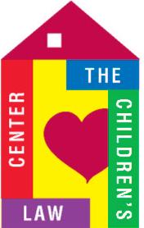

DEVELOPMENT COMMITTEE - May 11, 2017
A G E N D A

Welcome
- Where We Are
- Committee Roles and Responsibilities
- Strategic Plan

2017 Development Plan

Budget/fundraising
- Changing Grant Guidelines
- Gala
- Ideas for cultivating relationships with major donors

Upcoming Event
- Birdies for Charity/Travelers Championship, June 19 - 25
- Tribe Spinning Event – early July
- Ben and Jerry’s Ice Cream Fundraiser – TBD
- Moose Riders Bike Show – NA
- Hartford Evergreen Masonic Lodge #88 – 5K – September 17th

New Ideas for 2017 Fundraising

Adding Others to Committee
Next Meeting Date (s)

Misc/Other

