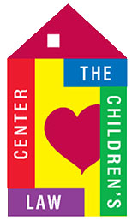
DEVELOPMENT REPORT – January 2017

GRANTS
Received:
Ion Bank $1,000

Applications/Reports:
Ensworth Grant & Final Report $15,000
Connecticut Community Foundation resubmitted
“Cradle to Career Youth Development” Grant $ 5,000
Hartford Evergreen Lodge #88 $20,000

GALA 2016
- Recap Meeting Jan. 18 – conference call
- Final net profit $92,000
GALA 2017
- Planning to convene; meeting dates to be set
- New Co-Chairs: Barbara Aaron & Paddi LeShane
- Bushnell new venue, new format
- Sponsorship solicitations a priority

OTHER EVENTS
- LuLaRoe clothing fundraiser Feb. 16 – spread the word. Flyers available.
- Brackets for Good
- Rally & Information Feb. 7
- Tournament Feb. 24-March 31
- More information to come – be prepared to give!

