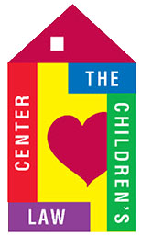
DEVELOPMENT REPORT – February 9, 2017

GRANTS
Received (as of 1-31-17):
Hartford Foundation for Public Giving $ 18,500

Applications/Reports:
Charles Nelson Robinson (Bank of America) $ 5,000
American Savings Foundation Summer Intern $ 4,775

CONTRIBUTIONS
Received (as of 1-31-17): $ 5,156 (checks and paypal)

GALA 2017
- Meeting with Justine, Deb and Paige Abrams on Feb 1

OTHER EVENTS
- LuLaRoe clothing fundraiser Feb. 16 – please continue to spread the word. Flyers available.
- Brackets for Good
- Rally & Information - Feb. 7
- Tournament Feb. 24 - 31
- More information to come – be prepared to give!
- For consideration:
- Tribe Spinning Event, March
- Little league 3x3 soccer tournament
- CLC Open House
- Board / Staff meet and greet

DEVELOPMENT COMMITTEE
- Meeting schedule to be determine

