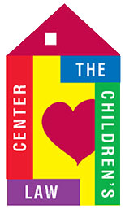
DEVELOPMENT REPORT – May 11, 2017
GRANTS
Awarded (month of April):
Petit Foundation (new, first time grant award) $ 3,500
Hartford Evergreen Lodge #88 $20,000

Applications/Reports (since last report):
JBGIA report submitted
Fund for Greater Hartford 2016 grant report submitted
Community Chest of New Britain & Berlin application $15,000
COSTCO Wholesale $20,000*
*new potential grant funding

CONTRIBUTIONS
Received (month of April): $ 2,701

GALA 2017
- It’s OFFICIAL! The Gala will be held at Delamar West Hartford, Thursday, November 30th
- Dornenburg Kallenbach Advertising - has agreed to help with the Gala at no cost to CLC
OTHER EVENTS
- Birdies for Charities – pledge cards/letters sent. Social media campaign underway
(as of April 30 we’ve raised $750 thru BFC)
- Tribe Spinning Event - will be scheduled, probably beginning of July
- Ben and Jerry’s Ice Cream Fundraiser - ice cream – yum – in the planning stages!

DEVELOPMENT COMMITTEE
- Meeting 5-11-17

MISCELLANEOUS

